Introduction to PolicyMap

Overview: When studying policy topics like public health or urban planning, it can be illuminating to see how concepts from class exist in the real world. Finding real-world conditions is possible by referring to data collected by sources like the Census Bureau or CDC. By visualizing these kinds of data on a map, students can investigate and demonstrate patterns that might not be apparent on a spreadsheet to ultimately develop recommendations for for addressing current issues in different fields. These exercises will go over, step by step, how to interpret data on a map.

For these exercises, you’ll need to be using your university’s PolicyMap license; consult your librarian for instructions on logging in.

Exercise 1: Making a map and interpreting it

To start, let’s make a map of incomes (median household income) to see concentrations of higher incomes and areas in poverty.
On the Maps page, you’ll see a bar with data topics (“Demographics,” “Incomes & Spending,” “Housing,” etc.). We’re looking for income data, so click on “Incomes & Spending”.
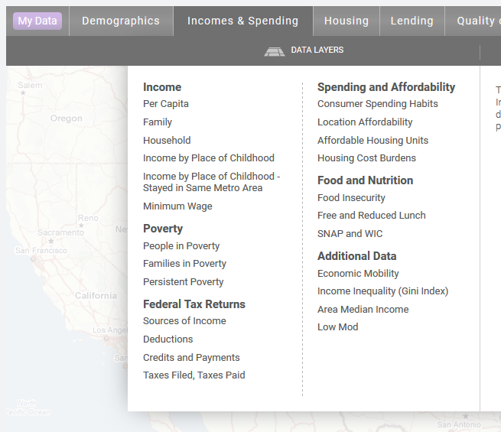
If you move your mouse over the menu, you’ll see that most items have a submenu. We’re interested in looking at household income, so go to the Income section and hover over Household. We want to see the Median Household Income for All Households, so click on that.
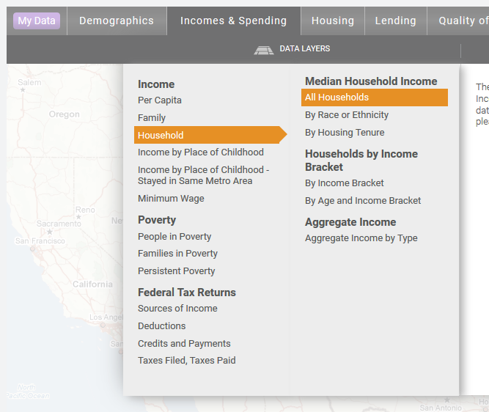
You should now see a map of the United States, with different shading throughout the map showing different income levels. If you look at the legend on the left of the map, you’ll see the source of the data is Census, the data represents the period of 2013-2017, it’s being shown in dollars, and it’s being shaded by county.
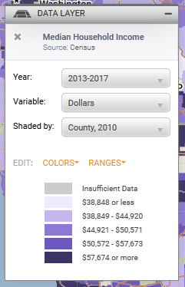
Shaded by “County” means that each block of color on the map is a single county. It says “County, 2010” because it’s showing the counties that existed in 2010.
Now we’ll look at a single city. In the location bar above the map, type the name of a city you want to look at (or the place you live), and click on the city in the suggestion menu.
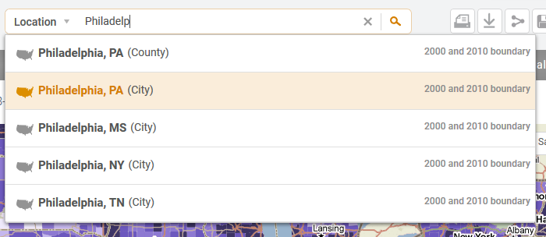
Look at the “Shaded by” menu in the legend. It should no longer say “County,” but have a smaller geography instead, like “Census Tract”.
Look for a lower-income area on your map, and click on it. This will bring up a bubble showing the actual values in the area you clicked on. The value at the bottom, in bold, is the highlighted area on the map. All the values above it are larger geographies that the highlighted area is inside.
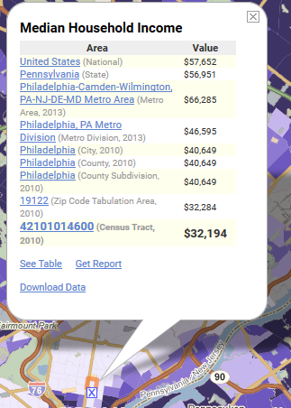
Here, we see that this census tract (an 11-digit code) has a median household income of $32,194. It’s in the city of Philadelphia, which has a median household income of $40,649. The state of Pennsylvania’s median income is $56,951, and in the whole United States, it’s $57,652.
What patterns can you discern by looking at the map? Looking at a map of Philadelphia, we can see that much of the city is made up of low-income neighborhoods, but that there’s a high-income area in the city center, and high-income areas in the surrounding suburbs.
Now, let’s add point data to the map. Let’s see where libraries are located in the city. To add libraries to the map, go to the Quality of Life data menu. Point-level data is in the third column.
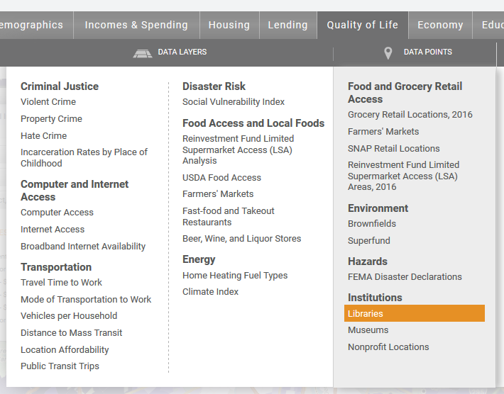
Each orange point on the map represents the location of a library. You can click on a point to see more information about it.

Questions:
Choose a different city, and create a map of life expectancy at birth. (Hint: Either look in the Health menu, or use the data search bar.)
1. What is the source of this data?
2. What time frame does the data represent?
3. What is the unit of the data?
4. What patterns do you see? What is the life expectancy in an area with high life expectancy? What is the expectancy in an area with low life expectancy?

Exercise 2: Finding targeted areas

Individual indicators can tell us a lot, but sometimes it’s even more useful to look at multiple indicators at the same time. Let’s try to find low-income neighborhoods that are also stable, which could be good places to consider for economic development projects or job skills training efforts.
For this, we’ll use the 3-Layer Maps tool on PolicyMap. Click on 3-Layer Maps at the top of the page to get started, and enter the city you want to investigate.
Next, choose indicators you want to be included in this map. We’ll want to look at median household income (in the “Incomes & Spending” menu) to identify lower income areas, residential vacancy rates (in the “Housing” menu; we’ll look at the Valassis data; see the image below) to show neighborhood stability, and percent of households who moved into their home before 1990 (also in the “Housing” menu, look at “Household Turnover” under “Additional Housing Data”) to indicate a rooted community.
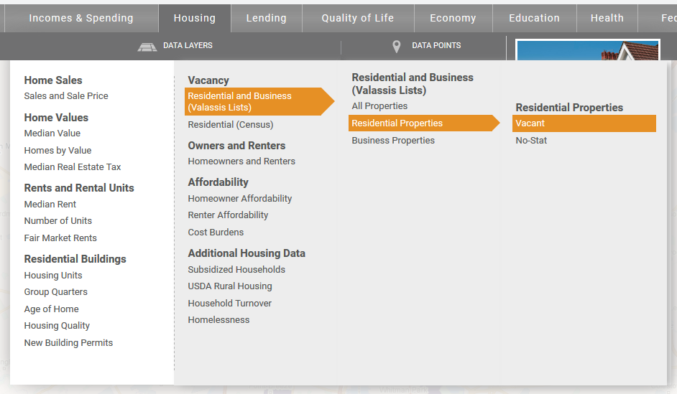
At first, the map will look completely purple. That’s because we haven’t yet narrowed our conditions.
Once these three are loaded, you’ll see them on the legend on the left side of the map. Each indicator has sliders and number boxes to set the minimum and maximum values you see on the map.
Let’s start by only showing low income neighborhoods. We’ll want to only show areas where medium income is below $45,000. Move the slider on the right to set the maximum to near $45,000. You can alternatively type $45,000 in the right box, then click outside the box for it to take effect.
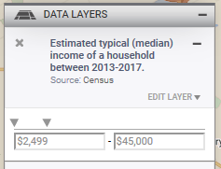
You should now see a lot of the purple areas on the map go away. Those were areas with higher median incomes.
Now set the vacancy indicator to show only areas where less than 5% of residential addresses are vacant. Fewer areas should be purple.
Finally, set the indicator for turnover to show only areas where 25% or more of households moved into their homes before 1990. This time, you’ll need to adjust the minimum slider, or the left box.
Your legend will look like this:
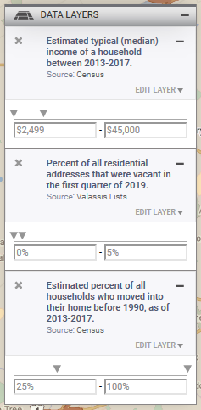
And the map will show only a few shaded areas. These are neighborhoods that have median low-income, but where vacancy isn’t causing blight and lots of people have lived in their homes for a while. Looking at community assets, such as libraries or nonprofit locations on the same map, you could identify possible partners for job training sites or economic development initiatives.

Questions:

Choose a different city, and create a map showing where public transportation riders take a long time to get to work. This will only require two layers. You’ll be able to find both layers in the “Quality of Life” menu, under “Transportation.”
1. What indicators did you choose, and why?
2. What criteria did you set for those indicators?
3. What types of decisions could someone make with this map?

Exercise 3: Downloading data

You may find that sometimes you need to use data from PolicyMap in other tools. Let’s say we want to find the counties in California with the highest unemployment rates. If we have a spreadsheet with this data, we can easily find this using software like Microsoft Excel.
First, go to the Maps page, and open the indicator you want data for. We want to look at annual unemployment data from the Bureau of Labor statistics, which can be found in the “Economy” menu.
Next, click on the download icon on the top right of the page:
You can choose whether to download layer data, point data, or layer data at the locations of your points. Right now, you only have layer data open, so you can click on “Next”.
You then need to choose the area you want to download data for. We want to download county data in California. Click on “Add” under “Pre-Defined Location.” Enter “California.” California will then be shown as your pre-defined location, and it will show that it’s shaded by county, which is what we want, so there’s no need to change it. Click on “Next,” and “Download CSV.”
Once the CSV file is downloaded, open it using a spreadsheet program like Microsoft Excel. Using the software, sort the rows by the unemployment rate (column D).
Questions:
1. What five counties have the highest unemployment rates in California, and what are their unemployment rates?
2. What counties have the lowest unemployment rates in California, and what are their unemployment rates?

